Inplantingsplan Paterkeskermis 2026
Bar

Inkom


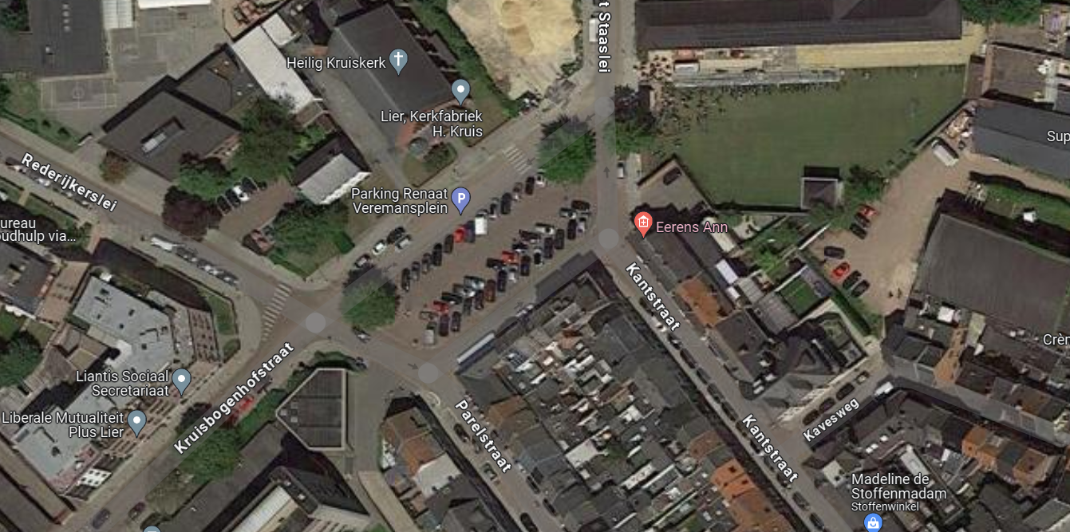
Podium
Inkom
parking artiesten 1
TENT
Koelwagen 1
Kleedkamer 1
springkasteel 1

wc

